(Approx. 440 words)


Mobile Highway
Items of interest to Mobile Device Users

One Dongle to Rule Them and In the Darkness, Bind Them
By Chris Woods, Member, Under the Computer Hood UG
February 2018 issue, Drive Light
www.uchug.org
1editor101 (at) uchug.org

When you get a wireless mouse, keyboard or any other of a myriad of wireless devices, what is common is that they all come with their own dongle. Most operate within the 2.4 GHz range and are mated to that device. Lose the dongle and you might as well kiss it goodbye. Ever noticed, on some of these devices, a tiny orange asterisk tattooed upon its surface?

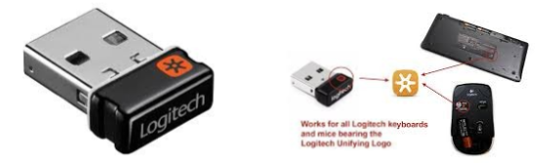

The orange asterisk symbol stands for Unifying Receiver, one of the dirty little secrets of peripheral manufacturers. Why have all your USB ports taken up with dongles when only one is required, the Unifying Receiver?

Logitech introduced its Unifying Receiver back in 2009. At first, it was only for Logitech’s line of devices, and it was limited to keyboards and mice. Many manufacturers have quietly included the same function on their peripherals. One of the pieces that make this magic work is the Logitech Unifying Software (http://support.logitech.com/en_us/software/unifying).

The software acts the same as a Bluetooth pairing, mating the device to the receiver. To set up this paring you first download the software. Then plug in the Unifying Receiver to a USB port and allow its driver to load. Finally, you run the software. When you run the software, there is a prompt that will ask you to turn each device (mouse, keyboard, etc.) off and on. If the device is compatible it is paired to that one receiver. To add other devices later you run the software again and follow the prompts. Right now, it’s still limited to six devices per receiver. A space saver for systems that are port limited, provided the device is recognized as compatible. As of this writing, according to Toms Hardware: “

A Logitech Receiver will pair up to 6 Logitech and non-Logitech peripherals, provided they both have the symbol. A Microsoft Receiver will pair most devices...but not Logitech.”

I have not seen any compatibility lists, but I can confirm from a tech standpoint that most peripherals that have the symbol pair without issue. I have a user at work that has a Logitech Unifying Receiver with an Asus keyboard, a Logitech mouse, and a Wacom drawing tablet. The limiting factor seems to be if your OS sees the device as an HID (Human Interface Device). For someone using many wired HID’s and wanting to switch to wireless to open USB ports the Unifying Receiver can come in very handy.

